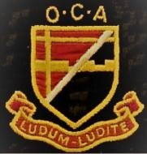
THE OLD CROYDONIANS’ ASSOCIATION

TOUR OF CROYDON MINSTER, CHURCH STREET, CROYDON CRO 1RN

TUESDAY 8 September 2026 at 2:00pm (optional lunch at 12 noon)

This event is one of the benefits of paid-up membership

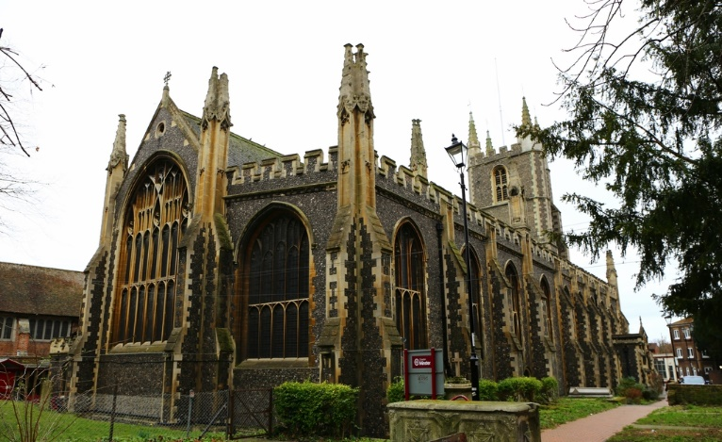
The Grade 1 listed Croydon Minster, better known to Old Croydonians as the Parish Church, has roots going back to Saxon times and is closely associated with the Archbishops of Canterbury. Six are buried there, including John Whitgift. The current Victorian Gothic structure was rebuilt by Sir George Gilbert Scott after a fire in 1867, but a church has stood on the site since around 809 AD, with the first physical record appearing in the Domesday Book. Royal visitors have included Henry VIII and Elizabeth I. The Minster’s Education Officer, David Morgan, will conduct a 60-75 minute tour. There is no charge for this but voluntary donations are welcome (especially if Gift Aided). There will be a short service at the end of the visit for those who wish to stay.
MEETING ARRANGEMENTS:
We shall meet at 12 noon for an optional lunch at own cost and have explored two possible venues. Firstly, The Fern opposite East Croydon Station at 100a George Street and, secondly, Ponte Nuovo, at 86-88 High Street under the flyover. All details can be found on their respective websites at www.fernlondon.co.uk and www.ponte-nuovo.co.uk. The Fern specialises in ‘small plates’ and is conveniently situated by the tram stop which takes you to the bottom of Church Street round the corner from the Minister. Ponte Nuovo is a traditional Italian restaurant about 10 minutes’ walk from the Minster. Please be at the Minster’s main door at 1:45 for a 2:00 start whether or not you are joining us for lunch.
Please let John Wade know in advance if you intend to have lunch and your
preference, if any. He will then go with the most popular choice.
Please reply to John no later than Friday 28 August 2026:
The tour is limited to 30 persons.

John Wade (SGSB 1962-69)
Telephone: 07733 224395 or 01444 457403
Email: johnwade@munrohall.com

