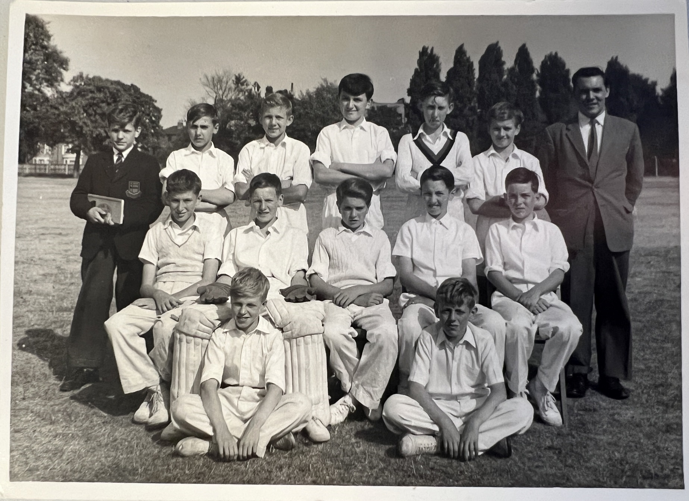
1959 Top Row Left to Right: ?, ?, Gibbons, Counter, Evans G, Wake, Mr. Holder
Middle Row: Hooper, Allen, Luck, Maynard, ?
Front sitting on ground: Mills, Tarrant

