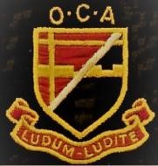

**ANNUAL REUNION & AGM 2025**

***MEMBERS OF THE OLD CROYDONIANS' ASSOCIATION WHO HAVE PAID THE ANNUAL SUBSCRIPTION***

***FOR 2024-25 ARE INVITED TO ATTEND THE ANNUAL REUNION EVENT & AGM 2025 ON***

**SATURDAY 26th JULY 2025 : 12:30 TO 5:00PM**

**AT THE BRIT SCHOOL - ADJACENT TO THE FORMER GIRLS' SCHOOL IN THE CRESCENT**

*Parking is available in the Girls' School playground: if the barrier is lowered, request entry via the intercom*

C:\Users\Valerie\Pictures\Old Croydonians\Magazine 2022\Squiggly line 3.jpg

**PROGRAMME FOR THE DAY (all timings approximate)**

12:30 onwards Arrival, refreshments and optional buffet lunch

2:15 – 3:15pm Guest speaker, Professor Paul Goddard (see overleaf)

“Between C S Lewis and Nietzsche : a Life in Medical Practice and Beyond”

followed by questions until 3:45pm

4:00 pm AGM

5:00 pm Event ends

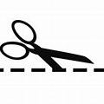

……………………………………………………………………………………………………………………………………….

**BOOKING FORM FOR OCA REUNION & AGM 2025**

I/we wish to attend and order lunch @ £10 per person .......................................................................................

I/we wish to attend but without lunch (no charge) ...........................................................................................

Preferred name(s)....................................................................................................................................................

Telephone .....................................Email ............................................................. Years at school........................

I/we enclose a cheque for £.............(£10 per person for the lunch) payable to The Old Croydonians’ Association

or

I/we confirm a bank transfer for £............. (£10 per person for the lunch) was made on …………………………………….

to The Old Croydonians’ Association, sort code 20-24-61, account no. 50676489.

*Tea/coffee and biscuits will be available for everyone (no charge)*

**Please return form no later than Tuesday 15th July 2025 to** **Bob Smith, 14 Foxearth Road, South Croydon CR2 8ED Telephone: 07941 857224/020 8657 3423, email bobskate314@gmail.com**

**Our Speaker at 2:15pm is**

**PROF PAUL GODDARD MD FRCR FBIR FHEA FRSM**

**(at the school 1961-68)**

**“BETWEEN C S LEWIS AND NIETZSCHE:**

**A LIFE IN MEDICAL PRACTICE AND BEYOND”**

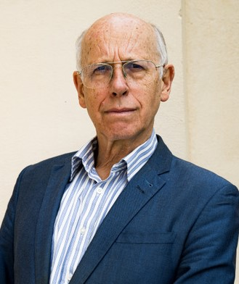

*Neil Bennett (1960-67), former head boy and BBC journalist*, will conduct an informal interview with Paul about the way in which his schooling shaped his life.

Paul elaborates: “I will mention my time at Winterbourne between 1954 and 1961 and reminisce about my years at Selhurst, with anecdotes about some of the masters, including the Headmaster (the ‘Baron’), Ed Short (Headmaster of the junior section) and Mike Fleet (the international athlete and OCA member who I am still in touch with). Also why it was that I, and the rest of my set, were taught logic and philosophy in the sixth form.

I then qualified as a doctor at University College, London, with a brief period at a missionary hospital in Nigeria, followed by training as a radiologist.

Afterwards, several years as an honorary Air Commodore in the RAF; a short spell in the Ukraine (30 years ago) providing medical services to the 43rd rocket army as they broke up the nuclear weapons (and how I am able to talk about this despite having signed the Official Secrets Act!); why I was left in charge of the air base in Cyprus; why I did not return to Colombia in South America; how I retired early to write 50 books, some of which have been best sellers, including *The Death of Science* with Angus Dalgleish and Sir Richard Dearlove (previously Head of MI6) and finally my new book *Profiteering from Doom*; and to conclude why playing music has assisted me throughout my life.

As a finale I will play a few bars of the blues on a slide guitar of my own design and construction”.

**PAUL’S INTERVIEW WILL LAST FOR APPROXIMATELY ONE HOUR PLUS TIME**

**AFTERWARDS FOR QUESTIONS.**

……………………………………………………………………………………………………………………………………………………………………