THE OLD CROYDONIANS' ASSOCIATION

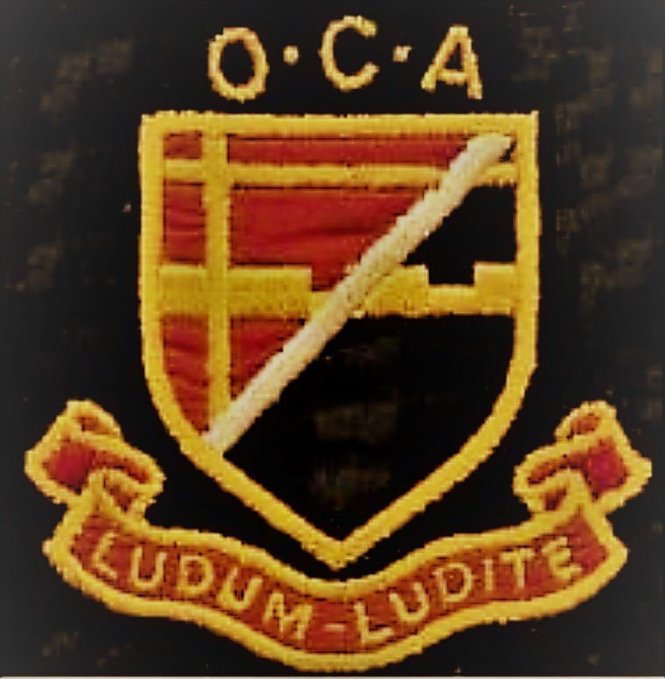

**ARRANGEMENTS FOR PAYING YOUR ANNUAL SUBSCRIPTION FOR 2025-2026**

# **£17 due from 1st September 2025**

There are four ways of paying

PLEASE RETURN THIS FORM AS SOON AS POSSIBLE INDICATING YOUR CHOICE OF PAYMENT METHOD WITH A TICK (✓)

### ...............I enclose a cheque for £17 made payable to "The Old Croydonians' Association"

**OR .............I have arranged a Standing Order of £17 at my Bank to be paid each year on (date)**

**OR .............I have made a BACS payment of £17 on (transaction date)**

**OR .............I have made a PayPal payment of £17 on (transaction date)**

*If paying by Standing Order, BACS or PayPal,* ***please use as a reference your surname followed by your initials****. It is essential to include these details so that we can identify your payment in the OCA's bank statements*

**Please return this form for our records even if you pay by Standing Order, BACS or PayPal**

*NOTE: If you are a member who is the wife/husband/partner of a member living at the same address you are entitled to Joint membership for a single payment of the £17 subscription*

### NAME....................................................................... Signature...........................................................

Joint Member's name (if applicable)...............................................................................

**ADDRESS**.......................................................................................................................................................

................................................................................................................Post code......................................

Telephone .....................................................Email address.........................................................................

***If paying by SO or BACS our Bank details are: Old Croydonians Association:*** *Account no:* ***50676489*** *Sort code:* ***20-24-61***

***If paying by PayPal the link is:*** <https://www.paypal.com/cgi-bin/webscr?cmd=_s-xclick&hosted_button_id=Q3M3DWG8VWM6L>

#### If you have any queries

*please address them to the Treasurer using the details below or telephone 020 8667 0184*

**PLEASE POST THIS FORM WHEN COMPLETED TO:**

**THE OCA TREASURER, John Cook 39, Alton Road, Croydon CR0 4LZ**

**OR SCAN AND EMAIL IT TO:** [*treasureroca1904@*](mailto:treasureroca1904@)*gmail.com*

**THANK YOU - YOUR CONTINUED SUPPORT IS VERY MUCH APPRECIATED**