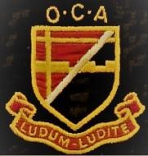

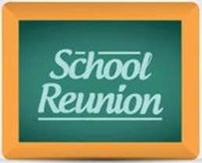

AND AGM 2024

MEMBERS OF THE OLD CROYDONIANS' ASSOCIATION WHO HAVE PAID THE ANNUAL SUBSCRIPTION
FOR 2023-24 ARE INVITED TO ATTEND THE ANNUAL REUNION EVENT & AGM 2024 ON
SATURDAY 20th JULY 2024 : 12:30 TO 5:00PM
AT THE BRIT SCHOOL - ADJACENT TO THE FORMER GIRLS' SCHOOL IN THE CRESCENT

Parking is available in the Girls' School playground: if the barrier is lowered, request entry via the intercom

PROGRAMME FOR THE DAY (all timings approximate)

12:30 onwards Arrival, refreshments and optional buffet lunch

2:30 – 3:10pm Guest speaker, Simon Parnall (see overleaf)
“The Development and Future of Digital Broadcasting and Online Media”

3:10 – 3:30pm Questions to Simon

4:00 pm AGM

5:00 pm Event ends

……………………………………………………………………………………………………………………………………….
BOOKING FORM FOR OCA REUNION & AGM 2024

I/we wish to attend and order lunch @ £10 per person .......................................................................................
I/we wish to attend but without lunch (no charge) ...........................................................................................
Preferred name(s)....................................................................................................................................................
Telephone .....................................Email ............................................................. Years at school........................

I/we enclose a cheque for £.............(£10 per person for the lunch) payable to The Old Croydonians’ Association
or
I/we confirm a bank transfer for £............. (£10 per person for the lunch) was made on …………………………………….
to The Old Croydonians’ Association, sort code 20-24-61, account no. 50676489.
Tea/coffee and biscuits will be available for everyone (no charge)

Please return form no later than Wednesday 3rd July 2024 to Bob Smith, 14 Foxearth Road, South Croydon CR2 8ED Telephone: 07941 857224/020 8657 3423, email bobskate314@gmail.com

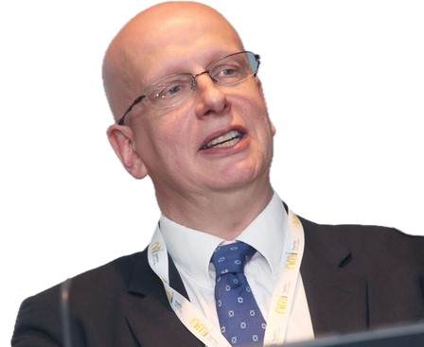

Our Guest Speaker at 2:30pm is
SIMON PARNALL
(at the school 1970-77)

“THE DEVELOPMENT AND FUTURE OF DIGITAL BROADCASTING AND ONLINE MEDIA”

Simon writes: After my degree in Physics at Imperial College, London, I worked for BBC R&D for 20 years, NDS/Cisco for 15 years and I now serve as Principal Adviser, Broadcasting and Media Technology for Ofcom (also with responsibility for our technical work in climate change). I will talk about the rise of digital broadcasting (covering teletext, RDS, DAB, DVB, the PVR and online services - in some of which I have played a leading role) and the challenges ahead (including distribution and climate change). I will incorporate one or two interactive demonstrations and I will encourage people to think about the consequences of a world in which every programme ever made is accessible right now, the value of ‘now’, and the vital job of educating young and old alike in media literacy.
Very importantly for our audience, I’d like to take some time to share how the masters at Selhurst played a really important role in my life during times of personal difficulty and gave me the confidence to play the part I have in the above.

Crystal Palace, Daley Thompson and Sebastian Coe might feature too!

SIMON’S TALK WILL LAST FOR APPROXIMATELY
40 MINUTES PLUS TIME AFTERWARDS FOR QUESTIONS.

